|  |  |  |  |  |
| --- | --- | --- | --- | --- |
| **FOOD DIARY**  Day: Sunday/**Day 1** | | | | |
| **TIME** | **PLACE** | **FOOD** | **AMOUNT EATEN** | **HOW PREPARED** |
| 10:00 am | Home | Eggs +Bread | 2 scrambled eggs  2 slices of whole wheat toast bread | Whisk eggs, salt and pepper in small bowl. Melt butter in non-stick skillet over medium heat. |
| 10:40 am | Starbucks | coffee + almond milk and sugars. | 1 cup of coffee with 2 tablespoons of almond milk and 4 sugars. | Bought from store |
| 1:30 pm | At work | Rice+ chicken+ water | 2/4 cups rice  3-ounce grilled chicken breast  1 bottled water | Chicken cooked with pepper powder, salt, oil. Rice cooked with water and some salt and pepper. |
| 3:15pm | At work | diet coke | 6 ounces | Bought from vending machine |
| 3:40pm | At work | Lays chips | 1 bag | Bought from vending machine |
| 4:00pm | At work | Water | 1 bottle of water | Bought from the store |
| 6:20pm | Mc Donalds | Sandwich + fries+ honey mustard | 1 medium fries  1 single cheeseburger sandwich. | Bought from the store |
| 8:00 | At home | Apple | 1 medium apple | Bought from the store |
| 9:30 | At Home | water | 1 small, bottled water | Bought from the store |
| Instructions:   1. List EVERYTHING you eat or drink on 3 consecutive, typical days. 2. Use 2 weekdays and 1 weekend day. 3. Include extras such as chewing gum, sugar, cream in coffee, ketchup, mustard, mayonnaise, salad dressing. | | | | |

|  |  |  |  |  |
| --- | --- | --- | --- | --- |
| **FOOD DIARY**  Day Monday/ Day 2 | | | | |
| **TIME** | **PLACE** | **FOOD** | **AMOUNT EATEN** | **HOW PREPARED** |
| 9:30 Am | At home | whole wheat toast with avocado spread and Tomato slice.  bottled water | 2 slice of whole wheat toast with 1avocado spread and 1 Tomato  1 small, bottled water. | Bought the toast in store. Seasoned the spread and the tomato with salt and pepper, olive oil |
| 4:15am | At home | Black tea | 1 black tea bag, 4tsp sugar. | Pour boiling water on the tea bag. |
| 11:00 | In the car | Water and medium apple | 1 half litre bottled water and 1 medium apple | Bought from the store. |
| 1:14pm | restaurant | Injera  Stew  Medium diet coke | 1 injera +a bout 1 medium bowel chicken stew. 1 medium diet coke | Restaurant prepared. |
| 3:00pm | At home | banana | 1 banana | Bought it from  The store. |
| 3:40 | home | Chai tea | 1 cup chai tea | 1 tea bag  3tsp sugar  ¾ cup milk |
| 7:00 | home | chips | 1 bag of lays chips | Bought from the store. |
| 8:40pm | home | Rice and mixed vegetables  Gingeral soda | 1 bowel of rice  ½ bowel mixed vegetables  1 can of gingerale. | -Fried mixed vegetables bought from the store.  - homemade rice seasoned with salt and pepper+ garlic powder |
| 9:15 pm | home | water | ½ litre bottle water | Bought from store |
| Instructions:   1. List EVERYTHING you eat or drink on 3 consecutive, typical days. 2. Use 2 weekdays and 1 weekend day. 3. Include extras such as chewing gum, sugar, cream in coffee, ketchup, mustard, mayonnaise, salad dressing. | | | | |

|  |  |  |  |  |
| --- | --- | --- | --- | --- |
| **FOOD DIARY**  Day Tuesday/ Day 3 | | | | |
| **TIME** | **PLACE** | **FOOD** | **AMOUNT EATEN** | **HOW PREPARED** |
| 9:00am | At home | Toasted bread  Peanut butter  Strawberry jelly  coffee | 2 slices of bread  2 tsp of peanut butter 2 tsp strawberry jelly  -1 cup of coffee + 3 tsp sugar. | Toasted bread  Store bought peanut butter and jelly. |
| 9:15 am | In car | Water | ½ litre bottled water | Store bought |
| 10:40 am | Starbucks | Coffee  Creamer  sugar | 1 medium coffee  3 sugars  2 creamers | Store prepared |
| 11:00am | Work | Lays chips  banana | 1 bag lays chips  1 large banana | Bought from store. |
| 1:30 pm | work | Pizza  Diet coke | 3 slices of chicken pizza  1 can diet coke | Store prepared |
| 2:00pm | At work | water | ½ bottled water | Bought from store |
| 4:00pm | At work | Apple  Almond butter | 1 medium apple  2 tsp almond butter | Bought from store |
| 8:00pm | home | Grilled salmon+ rice+ tomato and eggplants | Grilled 3 oz salmon  1 large tomato  ½ eggplants  ¼ rice | Boile and prepare rice seasoned with pepper and salt.  Mix with prepared fried egg and tomatoes. |
| 9:15pm | home | Mixed nuts + water | 1 Hand full of mixed nuts. ½ litre bottled water | Bought from store. |
| Instructions:   1. List EVERYTHING you eat or drink on 3 consecutive, typical days. 2. Use 2 weekdays and 1 weekend day. 3. Include extras such as chewing gum, sugar, cream in coffee, ketchup, mustard, mayonnaise, salad dressing. | | | | |

THE COMMUNITY COLLEGE OF BALTIMORE COUNTY

SCHOOL OF HEALTH PROFESSIONS

DENTAL HYGIENE PROGRAM

Nutrition and Biochemistry in Dentistry

**DNHY 124**

**Carbohydrate Intake Analysis Worksheet:**

**Day 1**

|  |  |  |  |
| --- | --- | --- | --- |
| **Fermentable CHO** | **Cariogenic?** | **Reason** | **Enamel Exposure Time** |
| Bread | yes | Contains processed carbohydrate. | 40 Minutes |
| Added sugar in the coffee | yes | Contains fermentable carbohydrate such as Sucrose | 30 minutes |
| Diet coke | yes | The carbonation and acidity of the soda may also contain artificial sweeteners that may contribute to cariogenic. | 40 minutes |
| Lays chips | yes | Its carbohydrate and Starch content | 30minutes |
| Honey Mustard | yes | Its natural sugar content (honey) | 40 minutes |
| Potato fries | yes | Due to high carbohydrate content, Starch. | 30 minutes |
|  |  |  |  |
|  |  |  |  |
|  |  |  |  |
|  |  |  |  |
|  |  |  |  |
|  |  |  |  |
|  |  |  |  |
|  |  |  |  |
| **TOTAL EXPOSURE TIME: 180 minutes**  **Day 2** | | | |
| **Fermentable CHO** | **Cariogenic?** | **Reason** | **Enamel Exposure Time** |
| Bread | Yes | Processed carbohydrate | 40 minutes |
| Added sugar in the black tea | yes | Fermentable carbohydrate, sucrose content | 50 minutes |
| Diet coke | yes | The carbonation and acidity of the soda may also contain artificial sweeteners that may contribute to cariogenic. | 30 minutes |
| Added sugar in the chai tea | yes | Sucrose content | 50 minutes |
| Chips | yes | Its carbohydrate and starch content | 30 minutes |
| Ginger ale/ Soda | Yes | High sugar / sucrose content and Acidity. | 50 minutes |
|  |  |  |  |
|  |  |  |  |
|  |  |  |  |
|  |  |  |  |
|  |  |  |  |
|  |  |  |  |
|  |  |  |  |
|  |  |  |  |
|  |  |  |  |
|  |  |  |  |
| **TOTAL EXPOSURE TIME: 250**  **Day 3** | | | |

|  |  |  |  |
| --- | --- | --- | --- |
| **Fermentable CHO** | **Cariogenic?** | **Reason** | **Enamel Exposure Time** |
| Bread | yes | Processed carbohydrate content | 40 minutes |
| Strawberry jelly | yes | High sugar content/ Sucrose, the stickiness consistency | 40 minutes |
| Peanut butter | yes | The stickiness consistency | 40 minutes |
| Added sugar in coffee | yes | Sucrose content | 50 minutes |
| Added creamer in the coffee | Yes | May contain added sugar | 50 minutes |
| chips | yes | Its carbohydrate and starch content | 30 minutes |
| Pizza and coke consumed together | No | Carbohydrates in pizza and soda will be neutralized by fat and Protin of other components of pizza ( chpt 18 p 363). | 0 minutes |
| Diet coke | yes | The carbonation and acidity of the soda may also contain artificial sweeteners that may contribute to cariogenic. | 50 minutes |
|  |  |  |  |
|  |  |  |  |
|  |  |  |  |
|  |  |  |  |
|  |  |  |  |
|  |  |  |  |
|  |  |  |  |
| **TOTAL EXPOSURE TIME: 300 minutes** | | | |

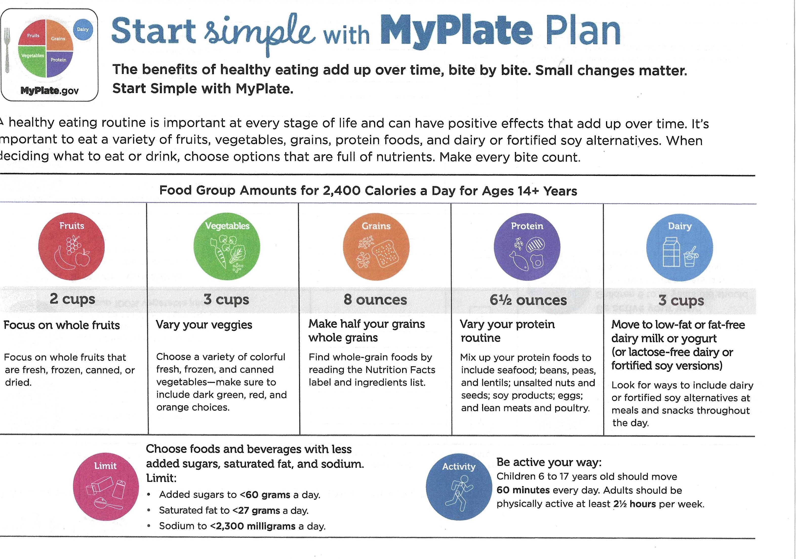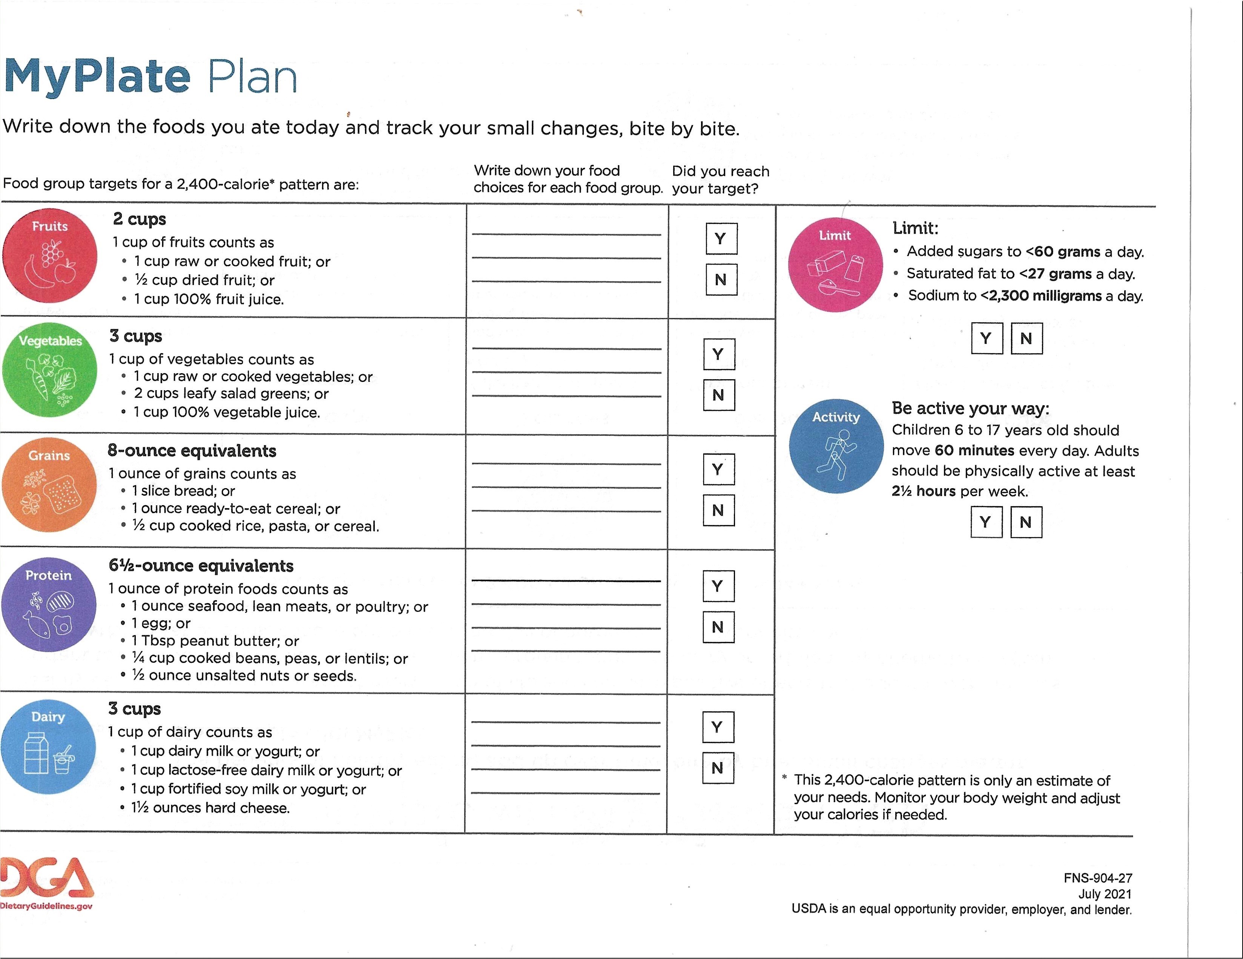

**Health History**

Mr. Benti is a patient who presented for a dental cleaning at the Community College of Baltimore County. Benti is a 38-year-old African American male with no significant medical history at this time. There are no known allergies or physical limitations associated with him, and his blood pressure is within the normal range. He has not undergone any medical surgery and does not require any modifications to his treatment based on the ASA classification.

Patient Profile

Age: 38

Gender: Male

Ethnicity: Black/African American

Blood Pressure:112/76

ASA Classification: I, no modification on treatment required

Height: 5’10’’

Weight: 143 Lb

BMI: 20.58 normal wight range.

**Dental History**

The patient has a history of having all four wisdom teeth removed due to caries lesions, indicating a previous issue with dental decay. The patient reports brushing their teeth twice a day with manual toothbrushing and using fluoride toothpaste but does not mention regular flossing or mouth rinsing. Additionally, the patient has not had a professional dental cleaning in years and believes their oral hygiene is fair.

Based on clinical assessments, the patient has a probing range of 4-5mm on more than 30% of their teeth, and bleeding on probing in less than 10% of their teeth, indicating a possibility of periodontitis, which is a condition that affects the gums and supporting structures of the teeth. There is localized moderate to severe subgingival and supragingival calculus on the lower anterior and posterior lingual areas, as well as slightly generalized interproximal calculus. Radiographically, interproximal calculus is evident in the majority of areas. The patient has no dental restorations. Based on the clinical assessment and radiographs, the patient is classified as a calculus 3, Perio B patient. Their initial plaque-free index is 75%, indicating room for improvement in plaque control. No active caries lesions were identified during the assessment.

Social History

Based on Benti's social history, he migrated from Ethiopia to the United States 9 years ago and currently works full-time, prioritizing his career to support himself and his family back home. He does not have a college education but remains dedicated to his work. Benti shares a two-bedroom flat with a friend and has limited time for social events or exercise due to his work commitments. Despite his challenges, he maintains strong ties with his cultural background and his family.

Benti mentioned that he shops for groceries weekly from Walmart and has no financial concerns about buying food, although he faces challenges in finding time to cook at home due to his busy schedule. This information about Benti's social history provides insight into his lifestyle and potential challenges in maintaining a healthy diet and oral hygiene habits. Taking these factors into consideration, tailored dietary and oral hygiene recommendations can be developed to suit Benti's unique circumstances and support his oral health goals.

Nutritional History

Benti's eating choices go toward traditional Ethiopian home-cooked dishes, with meat or chicken as protein sources of choice. He does, however, acknowledge that salads and vegetables are not his first picks.

Benti also claims that, due to his hectic schedule, he frequently eats at fast food places, which could indicate a higher intake of processed and potentially less healthy foods. He also mentioned drinking coffee once or twice each day and drinking homemade chai tea after work.

Benti also notes that he eats snacks in between meals, with potato chips and fruits being his favorites.

Patient selection

Benti's dental hygiene human needs deficit includes inadequate nutrition and dietary habits that are contributing to his periodontal disease.

Caries or periodontal risk assessment: The caries or periodontal risk assessment have aided in identifying the need for counseling by indicating that Benti is at high risk for periodontal disease due to factors such as poor oral hygiene, inadequate nutrition, and lifestyle habits such as limited time for cooking at home.

Possible links between clinical findings and diet: Benti's periodontal disease clinically identified may be linked to his diet through factors such as high carbohydrate intake, poor nutrition, and inadequate oral hygiene habits. These clinical findings suggest that his diet and oral hygiene habits may be contributing to his oral health issues.

Due to the presence of plaques and calculus, and lack of professional dental exams in the past couple years.

The objectives for providing Benti with nutritional counseling may include improving his dietary choices, promoting a balanced diet with adequate nutrients for oral health, educating him about the impact of diet on oral health, providing practical tips for incorporating healthy foods into his busy lifestyle, and promoting regular oral hygiene practices.

**Carbohydrate analysis**

Based on the three-day food diary, the patient's food consumption pattern appears to be dominated by carbohydrates, with frequent consumption of coffee/tea and snacks throughout the day. The patient's daily exposure to acid due to the consumption of fermentable carbohydrates is about 200 minutes, considered high risk, as it exceeds the recommended limit. The patient also consumes a good amount of water, but it is bottled water with no fluoride content, which may not provide adequate fluoride for tooth strength. Patients stated that it was a typical food intake during this period.

There is a significant absence of dairy products and grains in the patient's diet over the three days studied. This may indicate a potential nutrient deficiency, as dairy products and grains are important sources of essential nutrients. The patient's work nature seems to affect his food choices, with most snacks consumed at work and in his car, often consisting of prepared food from outside.

The high consumption of fermentable carbohydrates, coupled with the absence of dairy products and grains, may increase the risk of dental issues and nutrient deficiencies. Encouraging the patient to include a balanced variety of foods, including dairy products and grains, in his diet, as well as choosing tap water with fluoride content for hydration is beneficial for his overall health and well-being. A consultation with a registered dietitian or nutritionist is recommended to further assess and address the patient's dietary habits and nutrient intake.

Diet/Nutritional Modification and Recommendation Plan

Upon reviewing Benti's three-day food diary, it was found that he follows a consistent diet pattern. However, his busy schedule has led him to rely on fast food restaurants, potentially increasing his intake of processed and less nutritious foods. Additionally, his daily consumption of coffee and homemade chai tea may contribute to high levels of caffeine and sugar intake.

Although Benti's food preferences revolve around traditional Ethiopian home-cooked dishes with a liking for beef or chicken, his intake of salads or vegetables is minimal. This may indicate a deficiency in essential fruits and vegetables that are crucial sources of vitamins, minerals, and fiber.

Benti also indulges in snacking between meals, with potato chips and fruits being his go-to options. While fruits are a healthy choice, potato chips often contain high levels of sodium and carbohydrates, negatively impacting his overall nutritional quality. Based on the patient's health and nutritional history, it is recommended that Benti make the following modifications to his diet to improve his oral health.

1. Increase Fruit and Vegetable Intake: Benti's low intake of fruits and vegetables may result in deficiencies in vitamins, minerals, and fiber. It is recommended that he incorporate a variety of fruits and vegetables into his meals, aiming for at least 5 servings per day.
2. Reduce Fast Food Consumption: Benti's reliance on fast food restaurants may increase his consumption of processed and potentially less nutritious foods. It is recommended that he reduce his intake of fast food and instead opt for homemade meals using whole, unprocessed foods.
3. Limit Caffeine and Sugar Intake: Benti's daily consumption of coffee and homemade chai tea may contribute to high levels of caffeine and sugar intake. It is recommended that he limit his intake of these beverages and instead choose water or herbal teas as alternatives.
4. Choose Healthier Snack Options: Benti's preferred snack options, potato chips, and fruits, may have a detrimental impact on his overall nutritional quality. It is recommended that he choose healthier snack options such as nuts, seeds, or fresh vegetables with hummus or nut butter.
5. Consider incorporating more variety in his diet: While Benti's food preferences are rooted in traditional Ethiopian home-cooked dishes, incorporating more variety in his diet can provide him with a wider range of nutrients. He can try incorporating new foods or experimenting with different cooking methods to add more variety to his diet.
6. Seek Nutritional Counseling: Benti can consider seeking nutritional counseling from a registered dietitian to get personalized guidance on his dietary needs and goals. A dietitian can provide tailored recommendations based on his specific health needs and help him develop a sustainable and healthy eating plan.
7. Maintain Good Oral Hygiene: Benti should continue to brush his teeth at least twice a day with fluoride toothpaste, floss daily, and use mouthwash regularly. Regular dental cleanings and check-ups should also be scheduled to maintain good oral health and address any potential oral health issues promptly.

Conclusion

In conclusion, the nutritional analysis of Benti's diet revealed potential dietary connections to his clinically confirmed periodontal disease. Benti's goals for achieving recommendations include improving his dietary choices, increasing his intake of nutrient-rich meals, decreasing his intake of sugary and processed foods, and developing regular dental hygiene routines. The predicted outcome of applying these modifications is an improvement in Benti's oral health, including a reduction in gum inflammation and bleeding, improved gum health, and a lower risk of future oral health difficulties. Furthermore, the nutritional adjustments may help Benti's overall health and well-being, contributing to better overall health outcomes. To help Benti reach and sustain these goals and maintain long -term health and overall well-being, it is important to give continual support, monitoring, and education.

**Reference**

Stegeman, C. & Davis, J. (2018). *The Dental Hygienist’s guide to Nutritional Care.* (5th Edition). St. Louis, Missouri. Elsevier

**Nutritional Analyzing Rubric**

**Zehra Nuri**

**Health History**

**____________**

**10 pts -** Introductory statement, complete history reported: past & present health conditions, surgeries, current medications & their oral implications. physical limitations & allergies.

**3pts -** 1-2 areas inadequately described, no introductory statement

**1pts -** 3-4 areas inadequately described

**0pts -** Health history is missing, >5 areas inadequately described, information is too lengthy, does not follow guidelines

**Clinical & Dental History** **_____________**

**10 pts** -Significant assessment findings: EIOE, HTE, periodontal, PFI; calculus & perio class, dental habits, knowledge, ideas and attitude.

**7pts** - Information is not complete, some areas are blank, <2 areas could be expanded

**3pts** - 3-4 areas inadequately described.

**0pts** - Clinical and/or dental history not provided, information provided is too lengthy, does not follow guidelines

**Social, Nutrition History** **______________**

**10 pts** - Lifestyle, eating & shopping habits, living & transportation arrangements, financial concerns etc. History filled out, additional comments if necessary are added

**5pts** - 1-3 areas inadequately described/ not filled out.

**3pts** - 4-5 areas inadequately described.

**0pts** - Social history is missing, and/or >5 areas are inadequately described

**Patient Selection** **______________**

**15 pts** - Pt selection statement. ID dental hygiene human need deficit indicating need for diet counseling. ID possible link between clinical findings and patient’s diet, ID objectives of counseling.

**10pts** - Incorrect DH human need identified, missed a human need. ID incorrect clinical/dietary link

**0pts** - No DH human need identified, no link between clinical findings and DH human need, no pt selection statement

**Carbohydrate Analysis** **_______________**

**20 pts** – Food Diary form completed for 3 days to the best of client’s ability & supplemented with additional information if necessary for clarification. Findings of diary summarized; patterns briefly summarized. Correctly identified all fermentable CHOs and correctly determined the number of minutes of acid exposure. Provided 3-day average of acid exposure. Correctly and adequately provided a relationship to the health of the oral cavity.

**14 pts** – Incorrectly identified 1-3 fermentable CHOs, incorrectly determined number of minutes of acid exposure by less than 40 minutes, non-relevant findings addressed

**7pts** - More than 3 errors on CHO worksheet, incorrectly determined number of minuets of acid exposure by 40-60 minutes

**0pts** - >or< 3-day diary used, no patterns in dietary habits identified, incorrectly determined number of minutes of acid exposure by more than 60 minutes, no mention of diary being typical or atypical for pt

**Diet/Nutritional Modification Plan** **_______________**

**50 pts** - Clear connections made between nutrition and the oral cavity to include: diet/CHO intake/acid exposure and oral health that takes health history, dental history, medications, and lifestyle into consideration, Over/under consumption of nutrients addressed. ID disease promoting habits. Recommendations for modifications & expectations are realistic. ID short- & long-term goals

**40pts** - Some aspects of health, diet, meds overlooked. Could have addressed CHO or dietary issues more thoroughly, Gaps in findings that should have been addressed

**30pts** - Connections overlooked between frequency, form, timing, diet, meds & health. Recommendations not clear.

**20pts** – Dietary deficiencies, overindulgences &/or inadequacies not addressed, connections not made between patient selection and recommendations; diet, meds &/or health. Rec. unrealistic

**0pts** -Def, overindulge. & inadequacies not addressed, connections not made between diet, meds & health. Recommendations outside scope of RDH practice or are missing. Short- & long-term goals missing

**Conclusion** **_______________**

**10 pts** – Included expected success of program, included 3 specific, measurable, and realistic goals. Included changes made or anticipated making, provided an appropriate overall summary

**5pts** – Missing 1 goal, summary does not adequately bring together the major points of the assessment

**0pts** – Missing 2 or more goals, missing summary, does not discuss expected success of program

**Grammar** **________________**

**20 pts** - All grammar, spelling, capitalization, & punctuation are correct. Accurate word choice, quoted material when applicable. Headings for each section used. Paragraphs are organized.

**10pts** - (1-4) errors in grammar, spelling, capitalization, punctuation, missing 1 heading

**5pts** - Paper is disorganized, seems hurried. 5-7 grammatical errors. Missing 2-3 headings

**0 pt**s - More than 7 spelling/grammatical errors. HIPAA violation, missing more than 3 headings

**APA Format** **_________________**

**5 pts** - APA format is used accurately & consistently in the paper and the reference page. References complete and accurate using APA style.

**4 pts** - APA format is used with 1-3 errors

**3pts** - APA format is used with 4 or more errors

**0pts** - Missing bibliography. APA format not used

ASSIGNMENT TOTAL: ________/150

MISSING RUBRIC -10PTS

INFORMATION NOT IN THE CORRECT SECTION -10PTS

NOT USING SUBSCRIPT AS NEEDED -10PTS

NOT FOLLOWING GUIDELINES -15PTS

EACH DAY TURNED IN PAST DUE DATE -15PTS

FINAL GRADE: _______________